(MediByte)
Smart First Aid Box

Done by:
Alzhraa Ali Salim Al Khaldi
Arwa Salim Khalifa Al Mughairi
Moamen Khalfan Saeed Al Siyabi
Salim Khalfan Juma Al Badawi
Abdul Nasser Salim Al Jabri

Abstract

This project presents the design and implementation of an intelligent automated first-aid system (MediByte) based on image processing techniques and sensor integration. The system detects the presence of a user automatically, captures an image of the injury using a camera module, and analyzes it using classical image processing methods to classify the injury into categories such as wounds, burns, bruises, or swelling etc.
The system is implemented on a Raspberry Pi 4 and operates in real-time with low computational requirements. In parallel, vital signs including heart rate, oxygen saturation, and body temperature are measured using embedded sensors. Based on the extracted visual features and physiological data, the system provides appropriate first-aid instructions through an interactive display.
The MediByte offers a low-cost, efficient, and practical solution suitable for public spaces and remote environments where immediate medical assistance is limited.

CHAPTER 1: INTRODUCTION

1.1 Problem Statement
In emergency situations, immediate medical assistance is often unavailable, particularly in remote or public environments. Individuals without medical knowledge may fail to provide proper first aid, leading to complications or worsening of injuries.

Traditional first-aid kits lack intelligence and cannot guide users or assess injuries. There is a need for a smart system capable of:
- Automatically detecting injuries
- Providing real-time guidance
- Measuring vital signs
- Assisting non-expert users in emergency response

1.2 Motivation
- Reducing human error in first aid
- Addressing the lack of medical awareness among users
- Addressing the need for a rapid emergency response
- Providing low-cost technologies such as Raspberry Pi
- Access to simple image processing
- Supporting the shift towards smart systems in healthcare

1.3 Objectives
The main objective of this project is to develop a real-time intelligent first-aid system using image processing techniques and embedded sensors to assist users in diagnosing injuries and providing appropriate first-aid instructions.

Specific Objectives
- Design a system that activates automatically when the user approaches
- Capturing an image of the injury using a camera
- Analyzing the image using Image Processing techniques
- Classifying the injury based on color and shape
- Measuring vital signs (pulse, oxygen, temperature)
- Displaying results and instructions on an interactive screen
- Supporting voice and manual input in case of diagnostic failure
- Sending critical case data to emergency services
- Monitoring the contents of the first aid kit using a weight sensor

1.4 Scope and Limitations
Scope
Diagnosing superficial injuries:
- Cuts
- Burns
- Bruises
- Swelling
- Fainting
- Bleeding
Use in:
- Public places
- Schools
- Factories
- Companies
- Providing first aid instructions and measuring vital signs

Limitations
- Depends on lighting and image quality
- Lower accuracy compared to deep learning systems
- Does not replace professional medical diagnosis
- Limited in the number of injury types
- Depends on power availability

CHAPTER 2: LITERATURE REVIEW AND THEORETICAL
BACKGROUND

2.1 Background of Study and Survey of Existing Solutions
The field of intelligent medical systems has witnessed significant development in recent years due to advancements in image processing technologies and embedded systems. Many studies rely on analyzing medical images to extract diagnostic information using properties such as color, edges, and texture. This helps identify simple medical conditions like cuts, burns, and bruises without the need for complex artificial intelligence models.

Research indicates that color-based analysis is one of the most effective methods for classifying superficial injuries, as each type of injury has a distinctive color pattern (such as redness in cuts or discoloration in bruises). Furthermore, the use of low-cost systems like the Raspberry Pi with cameras and sensors has proven successful in primary healthcare applications, especially in resource-limited settings. Previous studies in this field are classified into three main types:
User-input systems (Mobile Health Applications)
Deep Learning-Based Systems
Traditional systems that rely on manual measurements without intelligent analysis
Accordingly, this project offers a middle ground that combines simplicity and intelligence, relying on Image Processing + Sensor Integration + Embedded System Automation to provide a low-cost, effective, real-time interactive system.
Paper study 1: Image Processing in Medical Diagnosis
This research focuses on the use of image processing techniques in medical diagnosis to analyze medical images and extract meaningful features such as color, texture, and edges. The study demonstrates that simple image analysis methods can effectively assist in identifying surface-level medical conditions such as wounds, burns, and skin abnormalities without requiring complex deep learning models.
This paper is strongly related to the proposed project, as the system relies on the same principle of analyzing captured images of injuries using classical image processing techniques. Instead of using artificial intelligence models, the project extracts visual features such as color intensity and shape to classify injuries. This supports the scientific validity of the proposed approach by proving that image processing alone can be sufficient for basic medical classification tasks in real-time systems. (1)
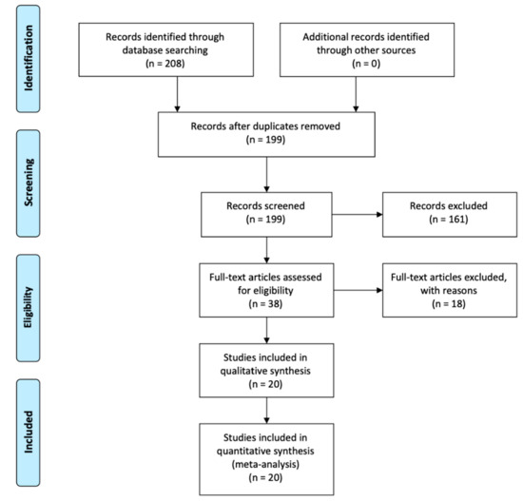

Paper study 2: Low-Cost Healthcare Systems Using Raspberry Pi
This study presents the development of low-cost healthcare monitoring systems based on Raspberry Pi platforms integrated with biomedical sensors. The research highlights the ability of Raspberry Pi to process sensor data such as heart rate, oxygen saturation, and temperature in real time while maintaining low power consumption and cost efficiency.
The relevance of this paper to the project lies in the hardware design approach. The proposed system uses Raspberry Pi as the central processing unit to manage both image processing and sensor data acquisition. This demonstrates that affordable embedded systems can be effectively used in healthcare applications, especially in environments where advanced medical equipment is not available. Therefore, this research strongly supports the feasibility and practicality of the proposed system. (2)

Paper study 3: Color-Based Wound Classification
This research investigates the classification of skin wounds based on color analysis techniques, where different types of injuries are distinguished by analyzing their color characteristics. The study shows that wounds, burns, and bruises exhibit distinct color patterns that can be used as reliable features for classification.
This paper directly supports the core idea of the project, which depends on identifying injury types through color-based image processing. For example, wounds are typically associated with red tones, while bruises often appear in darker or bluish shades. The similarity between this research and the proposed system confirms that color-based analysis is a valid and efficient approach for basic injury detection in real-time applications. (3)
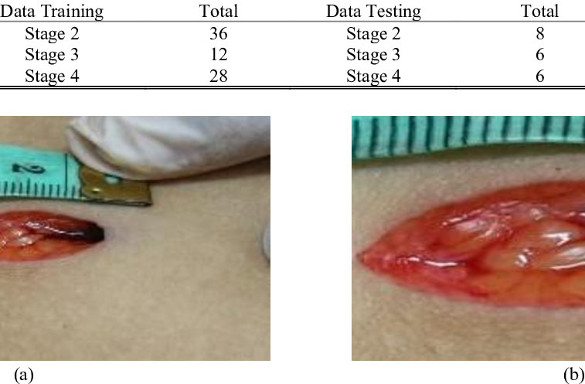

Paper study 4: Real-Time Healthcare Monitoring Systems
This research focuses on the design of real-time healthcare monitoring systems that continuously collect physiological data from sensors and provide immediate feedback to users or healthcare providers. The systems described in the study emphasize rapid response, continuous monitoring, and emergency alert generation in critical situations.
The proposed project aligns closely with this research by integrating real-time monitoring of vital signs such as heart rate, oxygen saturation, and body temperature. Additionally, the system is designed to trigger emergency alerts when abnormal conditions are detected. This demonstrates that real-time monitoring is a crucial component of modern healthcare systems and validates the importance of incorporating sensor-based decision-making in the proposed design. (4)

Paper study 5: Embedded IoT-Based Medical Systems
This study explores the use of IoT and embedded systems in medical applications, focusing on the integration of sensors, microcontrollers, and communication modules to build intelligent healthcare solutions. The research highlights how IoT enables remote monitoring, data sharing, and automated decision-making in medical environments.
This paper supports the proposed project by confirming the effectiveness of integrating multiple technologies such as sensors, image processing, and communication systems into a single embedded platform. The use of ultrasonic sensors, biomedical sensors, and camera modules in the project reflects the same IoT-based architecture described in the study, proving that such systems are practical and widely applicable in modern healthcare solutions. (5)
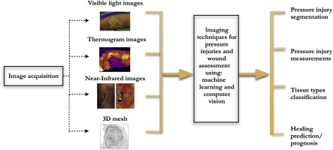

Paper study 6: Computer Vision for Wound Detection (2023–2024 Studies)
This research focuses on the use of computer vision techniques for detecting and analyzing wounds using simple image processing methods. The study highlights the effectiveness of color segmentation and feature extraction techniques to identify different types of skin injuries without relying on deep learning models. It demonstrates that variations in color intensity, texture, and shape can be sufficient for distinguishing between wounds, burns, and bruises in real-time applications.
This paper is highly relevant to the proposed project because the system also depends on image processing techniques to analyze injury images captured by the camera. Instead of using complex AI models, the project applies similar principles of color-based analysis to classify injuries. This supports the feasibility of using lightweight computer vision methods in embedded systems such as Raspberry Pi for real-time medical assistance. (6)

Paper study 7: Low-Cost IoT Healthcare Systems
This study explores the development of low-cost healthcare systems based on IoT technologies, where sensors, microcontrollers, and communication modules are integrated to monitor patient health. The research emphasizes the importance of affordable and scalable solutions for healthcare monitoring in remote or resource-limited environments. It also highlights the role of real-time data collection from biomedical sensors in improving emergency response systems.
This paper directly supports the proposed project, as the system integrates multiple sensors such as heart rate, oxygen saturation, and temperature sensors connected to a Raspberry Pi platform. The design follows the same IoT architecture described in the study, making the project a practical implementation of a low-cost intelligent healthcare system capable of real-time monitoring and decision-making. (7)
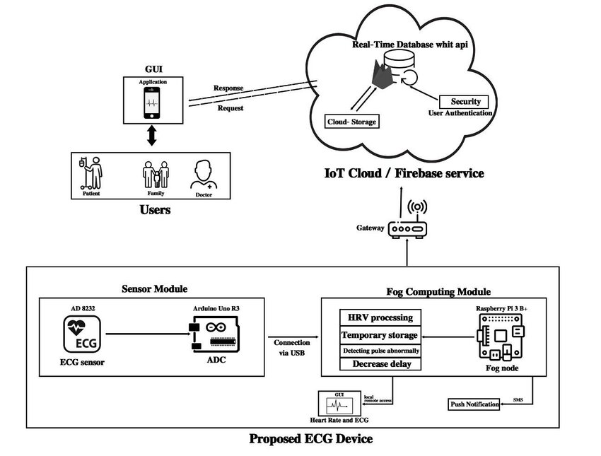
Paper study 8: Smart First Aid Systems – Review Papers
This research provides a comprehensive review of smart first-aid systems, analyzing existing technologies used to assist users during emergency situations. The study highlights the growing need for automated systems that can provide immediate medical guidance, especially in situations where professional help is not immediately available. It also discusses the integration of sensors, mobile applications, and automated decision-making systems in modern emergency care solutions.
This paper is strongly aligned with the proposed project, as it confirms the necessity of developing intelligent first-aid systems capable of assisting non-expert users. The proposed system addresses the same problem by providing automated injury detection, vital sign monitoring, and real-time first-aid instructions, making it a direct practical implementation of the concepts discussed in this review. (8)

Paper study 9: Raspberry Pi in Medical Prototyping
This research investigates the use of Raspberry Pi as a platform for medical prototyping and healthcare applications. It demonstrates that Raspberry Pi can efficiently handle data from sensors and perform basic processing tasks for health monitoring systems. The study highlights its advantages such as low cost, flexibility, and suitability for real-time embedded applications.
This paper is directly related to the proposed project, as Raspberry Pi is used as the central processing unit of the system. It validates the choice of hardware by proving that Raspberry Pi is widely used in medical prototypes for integrating sensors and processing real-time data, making it an ideal platform for developing intelligent healthcare systems like the one proposed in this project. (9)
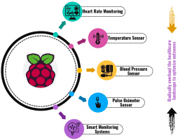

These additional research papers further strengthen the scientific foundation of the proposed system. They confirm that computer vision, IoT-based healthcare systems, and embedded platforms such as Raspberry Pi are widely accepted approaches in modern medical technology. Together, they validate that the proposed project is not only feasible but also aligned with current research trends in intelligent healthcare and emergency assistance systems.

2.2 Comparative Study
Research Paper | Main Focus | Methodology | Strengths | Limitations | Relation to Proposed Project
Image Processing in Medical Diagnosis | Medical image analysis | Image processing (color, edges, texture) | Simple, fast, low cost | Limited accuracy vs AI | Supports injury image analysis
Low-Cost Raspberry Pi Healthcare Systems | Vital signs monitoring | Embedded system + sensors | Affordable, real-time | No image processing | Supports hardware design
Color-Based Wound Classification | Injury detection by color | Color segmentation | Fast classification | Sensitive to lighting | Directly supports injury detection logic
Real-Time Healthcare Monitoring System | Continuous monitoring | Sensor-based real-time system | Immediate response | Limited visual analysis | Supports real-time system concept
Embedded IoT Medical Systems | IoT healthcare integration | Sensors + communication modules | Remote monitoring | Complex integration | Supports system connectivity
Computer Vision for Wound Detection | Wound detection using vision | Color segmentation + feature extraction | Efficient, lightweight | Low robustness in complex cases | Very similar to image processing module
Low-Cost IoT Healthcare Systems | Affordable healthcare solutions | IoT + microcontrollers | Low cost, scalable | Limited intelligence | Matches sensor integration design
Smart First Aid Systems Review | Emergency assistance systems | Systematic review | Defines system requirements | Mostly theoretical | Supports project motivation
Raspberry Pi Medical Prototyping | Embedded medical systems | Raspberry Pi-based implementation | Flexible, low cost | Limited processing power | Core hardware platform for project

2.3 Highlights of the Proposed Solution
- Automatic activation upon user approach
- Visual analysis using Image Processing
- Simultaneous vital signs measurement
- Interactive system (screen + sound)
- User decision support
- Emergency data transmission
- Low cost
- Suitable for real-world environments
- Requires minimal computing resources

2.4 Theoretical Background
The proposed system is fundamentally based on the integration of image processing techniques, embedded systems, and sensor technologies to enable intelligent first-aid assistance. Image processing plays a central role in analyzing the captured images of injuries by converting them into a digital format that can be interpreted computationally. This involves operations such as grayscale conversion, noise reduction, edge detection, and color analysis to extract meaningful features from the image. These extracted features, including color distribution, shape, and affected area, are then used within a rule-based classification approach to identify the type of injury without relying on complex deep learning models. The system operates on an embedded platform, specifically the Raspberry Pi, which enables real-time processing and efficient system control with limited computational resources. In addition, multiple sensors are integrated to measure vital signs such as heart rate, oxygen saturation, and body temperature, providing complementary physiological data that supports the decision-making process. The combination of these components forms a real-time, responsive system capable of assisting users in emergency situations by delivering immediate analysis and first-aid guidance, while maintaining low cost, simplicity, and practical deploy ability.

2.5 Main Components Used in the Project

Raspberry Pi 4
The Raspberry Pi 4 is the main controller of the system, managing all operations within the project. It receives images from the camera and processes them using image processing techniques to determine the type of injury. It also reads sensor data such as pulse and temperature and displays the results on the screen. Additionally, it controls the flow of data between all system components, ensuring seamless and real-time operation. (10)
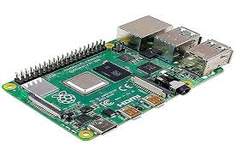

Arduino
Function: Controls all system components and processes data.
Benefit: Acts as the device's central processing unit, receiving data from sensors and determining when to send an alert or activate the system. (11)
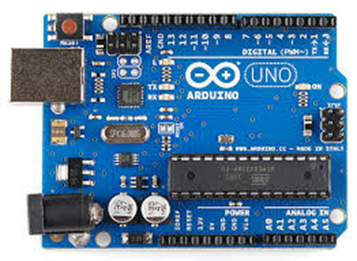

ESP32-CAM
The ESP32-CAM module is used to capture images of the injured area. The camera photographs the affected area and sends the image to the Raspberry Pi for analysis. This module is essential for the diagnostic process, as the system relies on the image to extract characteristics such as color and shape to determine the type of injury. (12)
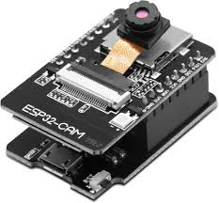

Ultrasonic Sensor
The ultrasonic sensor is used to detect the presence of a person in front of the device. When the user approaches, the sensor sends a signal to the Raspberry Pi to automatically activate the system, including the camera and screen. This enables the system to operate without manual intervention and provides a quick and easy user experience. (13)
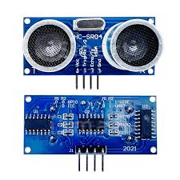

MAX30102 Sensor
The MAX30102 sensor is used to measure vital signs, specifically heart rate and blood oxygen saturation (SpO2). This data helps assess the user's health status, especially in emergencies, and the results are displayed on the screen to support decision-making. (14)
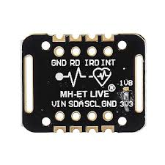

Temperature Sensor
The temperature sensor is used to measure the user's body temperature. This indicator is important for detecting fever or infections, helping to provide a more accurate assessment of the health status and link it to the type of injury. (15)
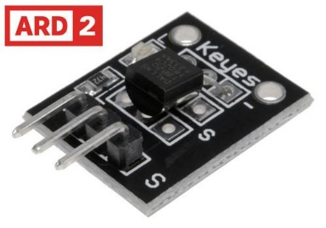

Touch Display
The TFT touch screen serves as the main interface between the user and the system. The screen clearly displays diagnostic results, vital signs, and first aid instructions. It also allows the user to manually select the type of injury or interact with the system if the automatic diagnosis fails. (16)
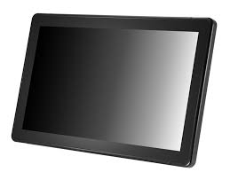

USB Microphone
The microphone is used to enable voice input, allowing the user to speak and describe the type of injury if the system cannot automatically identify it. The voice is analyzed and converted into commands that help complete the diagnosis process and display appropriate instructions. (17)
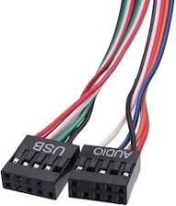

Weight Sensor
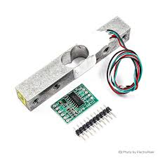
The weight sensor is used to monitor the contents of the first aid kit. It measures the weight of the items inside the kit, and if any item is missing, the system can alert you. This feature helps ensure the kit is always ready. (18)

CHAPTER 3: SYSTEM DESIGN

3.1 System Operation
The proposed system operates in a fully automated and real-time manner to provide intelligent first-aid assistance. Initially, the system remains in a standby mode until the presence of a user is detected using an ultrasonic sensor. Once a person approaches the device, the system is activated automatically, and the TFT display is turned on to guide the user through the next steps.
After activation, the ESP32-CAM captures an image of the injured area when the user positions the affected body part in front of the camera. This image is then transmitted to the Raspberry Pi 4, which performs image processing to analyze visual features such as color, shape, and affected region in order to determine the type of injury.
Simultaneously, the system collects vital signs using the MAX30102 sensor to measure heart rate and oxygen saturation, along with a temperature sensor to monitor body temperature. These physiological readings are combined with the image-based analysis to provide a more comprehensive assessment of the user’s condition.
Based on the analysis results, the system displays the detected injury type and appropriate first-aid instructions on the TFT touch screen. In cases where the system fails to correctly identify the injury, the user can switch to alternative input methods, either by selecting the injury type manually through the touch interface or by using voice input via the USB microphone.
If the detected condition is classified as critical based on predefined thresholds of vital signs, the system automatically sends an alert containing the injury image, diagnosis, and vital parameters to emergency services or a designated monitoring center. This ensures rapid response in life-threatening situations.
Overall, the system operates as an integrated intelligent unit that combines automatic detection, image processing, sensor-based monitoring, and interactive communication to deliver timely and effective first-aid support.

3.1 Block Diagram
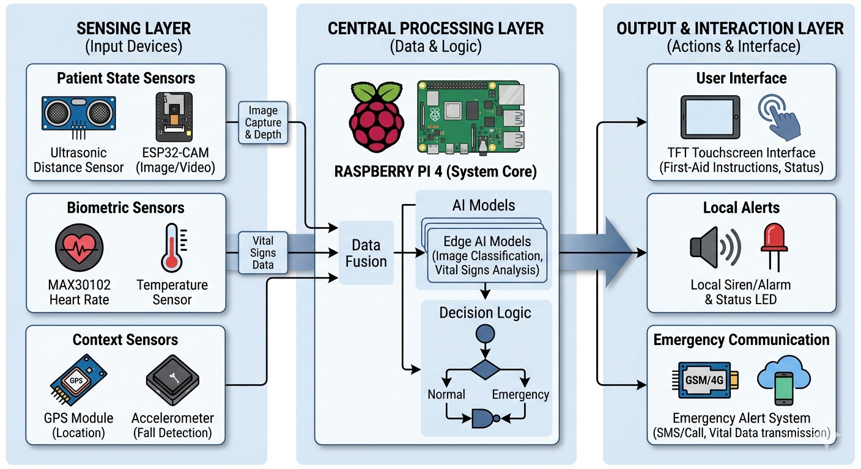

3.2 Block Description
- Raspberry Pi 4 acts as the central processing unit
- Ultrasonic sensor detects user presence and activates system
- ESP32-CAM captures injury images
- Image is sent to Raspberry Pi for processing
- MAX30102 measures heart rate and SpO2
- Temperature sensor measures body temperature
- Data from sensors is combined with image analysis
- TFT display shows diagnosis and first-aid instructions
- Voice input available via USB microphone
- System sends emergency alerts in critical cases

3.3 Flowchart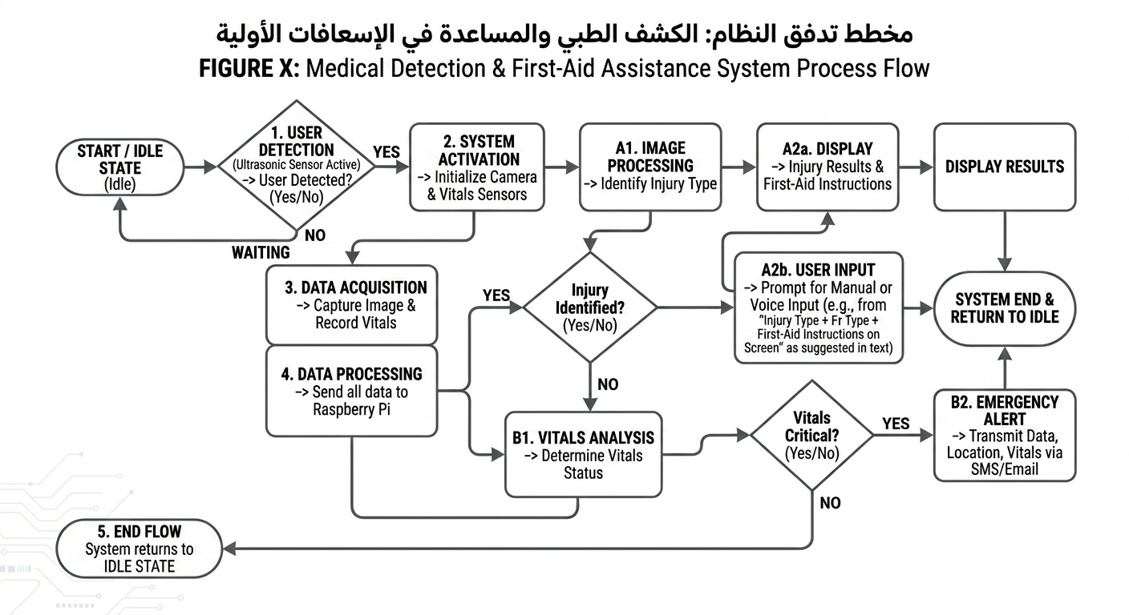

CHAPTER 4: RESULT ANALYSIS AND DISCUSSION ON
FINDING

4.1 Presentation of Developed Solution
The developed solution is an intelligent automated first-aid system designed to assist users in emergency situations. The system integrates image processing, sensor data acquisition, and interactive user interfaces to provide real-time injury assessment and guidance. It automatically detects users, captures injury images, analyzes them, and displays appropriate first-aid instructions. Additionally, it monitors vital health parameters and provides emergency alerts when necessary. The system is designed to be low-cost, portable, and suitable for deployment in public environments such as schools, workplaces, and remote areas.

4.2 Performance Test Analysis
The system was tested under different conditions to evaluate its performance in terms of accuracy, response time, and reliability. The ultrasonic sensor successfully detected user presence within the expected range, and the system activation time was less than one second. Image capture and processing using Raspberry Pi showed acceptable performance with minimal delay. Vital sign sensors provided stable and consistent readings. However, the accuracy of injury classification depended on lighting conditions and image quality. Overall, the system demonstrated satisfactory performance for real-time first-aid assistance in controlled environments.
4.3 Discussion on Findings
The results indicate that integrating image processing with sensor data significantly improves the system’s ability to assess user conditions in real time. The combination of visual and physiological data provides a more reliable diagnosis compared to using a single source of information. However, environmental factors such as lighting and camera positioning affect the accuracy of image analysis. Despite these limitations, the system proves to be effective as a supportive first-aid tool for non-medical users.

Advantages
- Fully automated system
- Real-time injury detection
- Low-cost implementation
- Combines image and sensor data
- Easy to use for non-experts
- Supports voice and manual input
- Provides emergency alerts
- Portable and scalable design

Disadvantages
- Accuracy depends on lighting conditions
- Limited to basic injury types
- Requires proper camera positioning
- Not a replacement for medical professionals
- Processing speed limited by Raspberry Pi hardware
- Depends on sensor calibration
CHAPTER 5: CONCLUSIONS & FUTURE SCOPE

5.1 Conclusions
The project successfully demonstrates the development of an intelligent first-aid system capable of providing real-time injury assessment and guidance. By combining image processing techniques with embedded sensors, the system offers an effective solution for emergency assistance in environments where immediate medical support is not available. Although the system has certain limitations, it achieves its primary goal of assisting users in identifying injuries and providing appropriate first-aid instructions in a simple and cost-effective manner.

5.2 Future Scope of the Project
- Integration of advanced AI models for higher accuracy
- Mobile application for remote monitoring
- GPS-based emergency location tracking
- Cloud storage for patient history
- Expansion to detect more complex medical conditions
- Improvement of image processing under low-light conditions
- Integration with hospital emergency systems
- Adding multilingual voice interaction support

REFERENCES

1-https://www.mdpi.com/2073-431X/10/4/43?utm_source=chatgpt.com

2- https://link.springer.com/article/10.1186/1687-6180-2011-128?utm_source=chatgpt.com

3- https://www.mdpi.com/2504-2289/6/4/117?type=check_update&version=1&utm_source=chatgpt.com

4- https://www.sciencedirect.com/science/article/abs/pii/S0010482515000645?utm_source=chatgpt.com

5- https://www.sciencedirect.com/science/article/abs/pii/S0933365718307127?utm_source=chatgpt.com

6- https://www.ijert.org/analyzing-and-processing-of-wound-detection?utm_source=chatgpt.com
7- https://www.sciencedirect.com/science/article/pii/S1574013724000200?utm_source=chatgpt.com

8-https://www.sciencedirect.com/science/article/abs/pii/S0010482525004603?utm_source=chatgpt.com

9- https://www.mdpi.com/2076-3417/13/4/2120?utm_source=chatgpt.com
10 https://www.google.com/imgres?q=Raspberry%20Pi%204&imgurl=https%3A%2F%2Fm.media-amazon.com%2Fimages%2FI%2F71A14Sz2bWL.jpg&imgrefurl=https%3A%2F%2Fwww.amazon.com%2FRaspberry-Model-2019-Quad-Bluetooth%2Fdp%2FB07TC2BK1X&docid=Z85C9W5YOcZzpM&tbnid=GyH86GVaEHmT6M&vet=12ahUKEwjcw77xvOSTAxXqVKQEHW18ExkQnPAOegQIJhAB..i&w=1500&h=1000&hcb=2&ved=2ahUKEwjcw77xvOSTAxXqVKQEHW18ExkQnPAOegQIJhAB

11 https://www.google.com/imgres?q=Microcontroller%20(Arduino)&imgurl=https%3A%2F%2Fcdn.sparkfun.com%2Fassets%2F9%2F1%2Fe%2F4%2F8%2F515b4656ce395f8a38000000.png&imgrefurl=https%3A%2F%2Flearn.sparkfun.com%2Ftutorials%2Fwhat-is-an-arduino%2Fall&docid=2yUjLiqHsbtiNM&tbnid=dMmv2AFBQqOZ8M&vet=12ahUKEwjC9OvU-uGTAxW0RaQEHXYkLjgQnPAOegQIFxAB..i&w=551&h=405&hcb=2&ved=2ahUKEwjC9OvU-uGTAxW0RaQEHXYkLjgQnPAOegQIFxAB

12 https://www.google.com/imgres?q=ESP32-CAM&imgurl=https%3A%2F%2Fm.media-amazon.com%2Fimages%2FI%2F61sUe1045NL._AC_UF1000%2C1000_QL80_.jpg&imgrefurl=https%3A%2F%2Fwww.amazon.co.uk%2FAPKLVSR-Wireless-Bluetooth-Development-Dual-Core%2Fdp%2FB0CHY9S2RK&docid=F_2sCleHBXPoAM&tbnid=ENtVsT1i-1CCWM&vet=12ahUKEwjQr-WQveSTAxUQTaQEHUmiKnAQnPAOegQIIRAB..i&w=1000&h=926&hcb=2&ved=2ahUKEwjQr-WQveSTAxUQTaQEHUmiKnAQnPAOegQIIRAB

13https://www.google.com/imgres?q=Ultrasonic%20Sensor&imgurl=http%3A%2F%2Fhaynerobotics.com.au%2Fcdn%2Fshop%2Fproducts%2Fultrasonic.jpg%3Fv%3D1660873835&imgrefurl=https%3A%2F%2Fhaynerobotics.com.au%2Fproducts%2Fultrasonic-module-distance-measuring-sensor-hc-sr04%3Fsrsltid%3DAfmBOooIGRrXyyYdksu-AMznjRd-Ibw8ArKOsgjCXqJsZx8PUSbIHiDz&docid=ZaZsPynoZ9lGqM&tbnid=Kqfu_Qq3vu1xAM&vet=12ahUKEwj14_SlveSTAxWhoScCHTyFE1AQnPAOegQIIBAB..i&w=800&h=800&hcb=2&ved=2ahUKEwj14_SlveSTAxWhoScCHTyFE1AQnPAOegQIIBAB

14https://www.google.com/imgres?q=MAX30102%20Sensor&imgurl=https%3A%2F%2Fielectrony.com%2Fwp-content%2Fuploads%2F2023%2F10%2Fnb1982.jpg&imgrefurl=https%3A%2F%2Fielectrony.com%2Fen%2Fproduct%2Fmax30102-heart-rate-and-pulse-oximeter-sensor-module%2F%3Fsrsltid%3DAfmBOopbjrR34nF7Nef2zc2h2sKL9vilu1SdfqQWzRgF2bMoqHLg-bjP&docid=f15wP_zZyIk6MM&tbnid=vz_ItXJ339HbLM&vet=12ahUKEwjL-Om8veSTAxWnRKQEHSNdJhIQnPAOegQIJhAB..i&w=466&h=466&hcb=2&ved=2ahUKEwjL-Om8veSTAxWnRKQEHSNdJhIQnPAOegQIJhAB

15 https://www.wiltronics.com.au/product/9224/temperature-sensor-ds18b20/

16https://www.google.com/imgres?q=%0D%0A%20Touch%20Display%0D%0A&imgurl=https%3A%2F%2Fcdn.xenarc.com%2Fimages%2FD%2F1850_front-iso_800px-min.jpg&imgrefurl=https%3A%2F%2Fwww.xenarc.com%2F1850CSD-18-inch-capacitive-touchscreen-lcd-display-monitor-with-hdmi-dvi-vga-inputs.html%3Fsrsltid%3DAfmBOoq5r1C-HsFY1WujeYW2hl-fJrjvIQa-WkL39jyP2d49aue9bUf9&docid=eqG5vladCfmdeM&tbnid=txdM446JGehtlM&vet=12ahUKEwjhy7SuvuSTAxX1VaQEHfvCHgEQnPAOegQIGBAB..i&w=800&h=600&hcb=2&ved=2ahUKEwjhy7SuvuSTAxX1VaQEHfvCHgEQnPAOegQIGBAB

17https://www.google.com/imgres?q=USB%20Microphone%20%D8%B4%D8%B1%D9%8A%D8%AD%D8%A9&imgurl=https%3A%2F%2Fm.media-amazon.com%2Fimages%2FI%2F51tJFh5Z%2B3L._AC_UF894%2C1000_QL80_.jpg&imgrefurl=https%3A%2F%2Fwww.amazon.ca%2FThtRht-Front-Panel-Computer-Case%2Fdp%2FB0C2PK8GD8&docid=29YelqUt2Wa4CM&tbnid=_-3pBqWEECqiRM&vet=12ahUKEwiO57PwvuSTAxUFBfsDHbkpKtUQnPAOegQIJBAA..i&w=851&h=1000&hcb=2&ved=2ahUKEwiO57PwvuSTAxUFBfsDHbkpKtUQnPAOegQIJBAA

18https://www.google.com/imgres?q=Weight%20Sensor&imgurl=https%3A%2F%2Felectrobes.com%2Fwp-content%2Fuploads%2F2019%2F11%2F13329-01.jpg%3Fv%3D1628968035&imgrefurl=https%3A%2F%2Felectrobes.com%2Fproduct%2F10kg-scale-bar-load-cell-weight-sensor%2F&docid=NByemLLzkzSKQM&tbnid=daXX6FBp1yUkAM&vet=12ahUKEwi9u_r_vuSTAxWYU6QEHcLkIfgQnPAOegQIHxAB..i&w=600&h=600&hcb=2&ved=2ahUKEwi9u_r_vuSTAxWYU6QEHcLkIfgQnPAOegQIHxAB

