Marine Rescue Device (Smart Marine Safety System)

Done by:
Arwa Salim Khalifa Almughairi.

ABSTRACT

The increasing number of maritime accidents, including boat capsizing, drowning incidents, and natural disasters, highlights the urgent need for advanced rescue technologies. This project proposes a Smart Marine Rescue Device equipped with GPS and Low Earth Orbit (LEO) satellite communication to ensure reliable emergency signaling even in remote ocean areas. The device is capable of transmitting real-time location data, sending distress alerts, and enabling voice communication with rescue authorities. Additionally, it integrates environmental data analysis to predict hazardous weather conditions, along with sensors for detecting impacts and boat overturning. Powered by solar energy and supported by a backup battery system, the device is designed to operate continuously under harsh marine environments. This system aims to enhance rescue response time, improve safety, and reduce fatalities in maritime emergencies.

CHAPTER 1: INTRODUCTION

1.1 Problem Statement
Marine accidents are a major safety concern worldwide, particularly for fishermen and small boat users. In many cases, accidents occur far from shore where there is no mobile network coverage, leading to delayed rescue operations.

According to international maritime safety reports, delayed response time is one of the main causes of fatalities in sea accidents. Many victims are unable to send their location, which makes rescue missions difficult and time-consuming.
Therefore, there is a need to develop a smart rescue system that can automatically detect emergencies and send accurate location data via satellite communication.

1.2 Motivation
this project aims to provide a reliable and efficient solution that ensures quick emergency response and enhances survival chances.
- Reducing marine accident fatalities
- Improving response time in rescue operations
- Enhancing safety for fishermen in Oman
- Using smart technology to solve real-life problems
1.3 Objectives
The main objective of this project is to design and develop a smart marine rescue device that can accurately detect emergencies, determine the user’s location, and transmit distress signals through satellite communication to facilitate rapid rescue operations.

Specific Objectives:
- To integrate GPS technology for accurate real-time location tracking.
- To enable long-range communication using LEO satellite networks.
- To design an automatic emergency alert system (SOS).
- To incorporate sensors for detecting collisions, capsizing, and falls.
- To implement environmental monitoring and weather prediction features.
- To provide night visibility using laser or LED lighting.
- To develop a sustainable power system using solar energy and backup batteries.
- To ensure device durability against harsh marine conditions.

1.4 Scope and Limitations
Scope:
- The device is designed for use in marine environments such as boats, ships, and individual users at sea.
- It focuses on emergency detection, location tracking, and communication with rescue authorities.
- It supports operation in remote areas where traditional communication networks are unavailable.

Limitations:
- Dependence on satellite availability and signal strength.
- High initial cost due to satellite communication technology.
- Limited battery capacity during prolonged absence of sunlight.
- Environmental factors such as extreme weather may affect performance.
- Requires periodic maintenance to ensure reliability.

CHAPTER 2: LITERATURE REVIEW AND THEORETICAL BACKGROUND

2.1 Background of study and survey of Existing Solutions
In recent years, marine safety systems have gained significant attention due to the increasing number of accidents involving fishermen and small boats. Several studies have proposed different solutions to improve rescue operations using modern technologies such as GPS, satellite communication, and wireless networks.

The first study: Low Earth Orbit (LEO) Satellite Communication for Emergency Applications (2022/2023) (1)
This study demonstrates that Low Earth Orbit (LEO) satellites are among the most efficient technologies for emergency systems due to their ability to provide fast and reliable communication in remote areas such as seas and oceans, where terrestrial networks are unavailable.
This paper supports the use of satellite communication in maritime rescue operations, as it:
- Enables the transmission of SOS distress signals from long distances.
- Provides real-time data transmission, such as GPS coordinates.
- Supports voice communication with rescue teams.

Studies indicate that LEO systems are characterized by:
- Low latency compared to traditional satellites.
- Wide coverage of maritime areas.
- High reliability in emergency situations

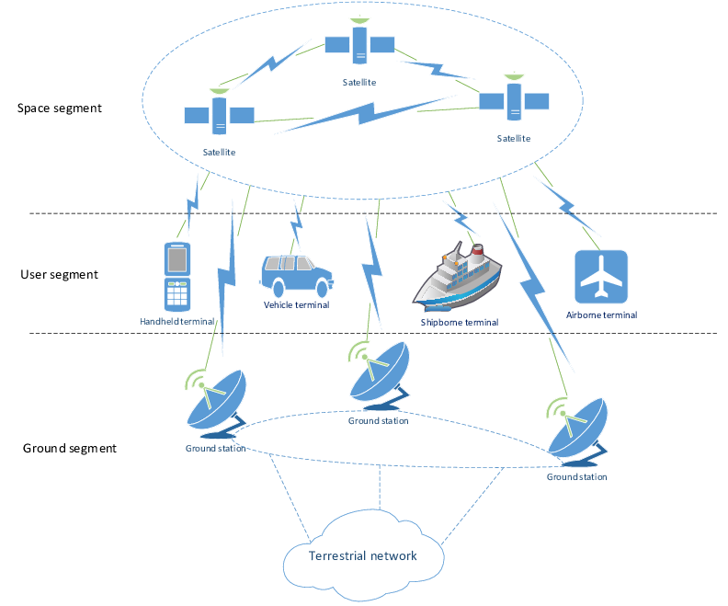
The second study:
(Maritime Search and Rescue & Emergency Beacon Systems – 2023). (2)
This study discussed the importance of emergency beacon devices such as EPIRB and PLB. These devices send distress signals along with GPS location to rescue centers via satellites. The research concluded that the use of such devices significantly increases survival rates and reduces rescue time.
Relation to my project:
Our project is based on the same concept but extends it by adding smart sensors, automatic accident detection, and solar power to enhance system reliability.
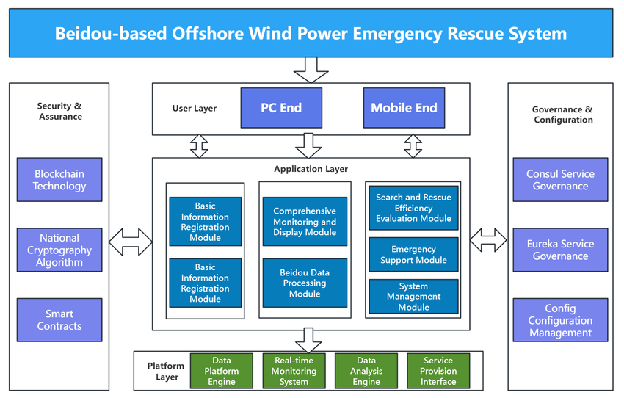

The third study:
(Personal Locator Beacons and EPIRB Systems – 2024). (3)
This research explained how personal locator beacons work in emergency situations. These devices transmit identification and location data through satellite networks to global rescue systems.

Relation to my project:
While these systems depend mainly on manual activation, our system introduces automatic detection using sensors, which reduces human error.
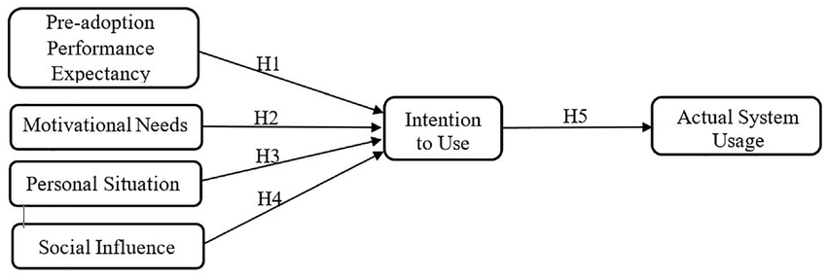
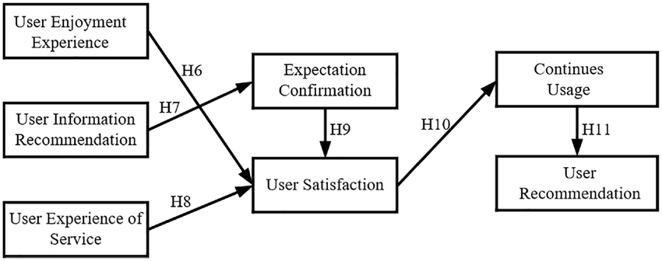

The fourth study:
(GPS-Based Emergency Response Systems – 2020).
This study highlighted the importance of GPS technology in emergency systems. It showed that GPS-enabled devices can significantly reduce the time required to locate victims and improve rescue efficiency.
Relation to my project:
GPS is a core component in our system, ensuring accurate location tracking during emergencies.

The fifth study:
IoT-based Smart Maritime Safety Systems (2021/2022). (4)
This study explores the use of the Internet of Things (IoT) in developing maritime safety systems by connecting sensors and smart devices to collect, analyze, and transmit data in real time.
This paper supports the idea that your device is not just a transmitter, but a fully integrated smart system that:

Uses sensors to detect:
Shocks
Boat capsizing
People falling overboard
Collects and analyzes data
Sends it automatically via satellite
Scientific Evidence:
Research indicates that maritime IoT systems:
Improve emergency response speed
Reduces reliance on human intervention
Provides continuous (real-time) monitoring
Contributes to hazard prediction, such as storms
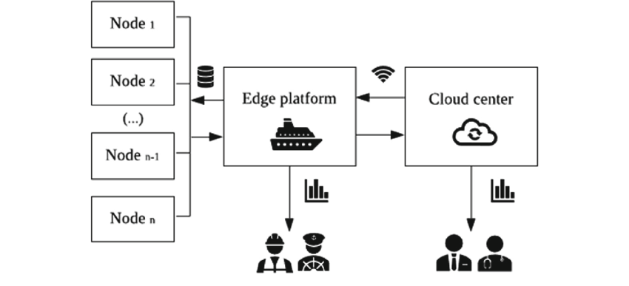

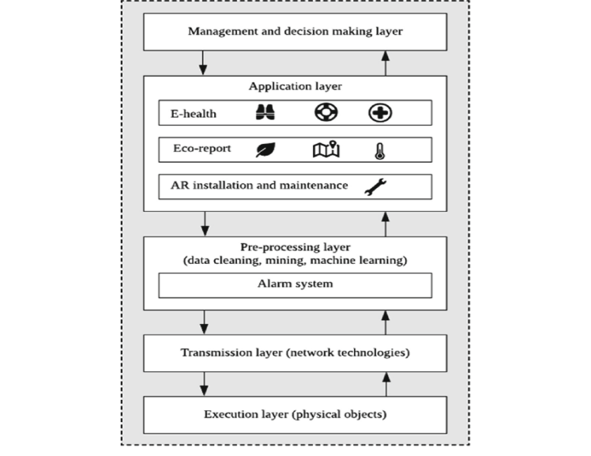

These studies confirm that integrating LEO satellite communication with IoT-based sensing systems provides a reliable and intelligent solution for maritime emergency response, which strongly supports the proposed smart marine rescue device.

2.2 Comparative Study
Existing work | Technology Used | Strengths | Limitations
Marine Search & Rescue Systems (2023) | Emergency Beacons | Reliable distress signaling, widely used | No real-time monitoring, limited intelligence
PLB Devices | GPS+satellite beacon | Accurate location tracking, global usage | Requires Manual activation, lacks automation
IoT-based Maritime Safety Systems (2021/2022) | IoT Sensors + Data Systems | Real-time monitoring, automation, smart detection | Requires integration, power consumption challenges
LEO Satellite Communication (2022/2023) | LEO Satellites | Wide coverage, low latency, reliable in remote areas | High cost, depends on satellite availability
GPS-based Emergency Systems (2020) | GPS Technology | High positioning accuracy | Depends on network availability, no direct communication

2.3 Highlights of the Proposed Solution

- integration of GPS with LEO satellite communication for long-range connectivity
- Real-time transmission of location and emergency signals (SOS)
- Support for voice communication via satellite during emergencies
- Automatic detection of accidents using sensors (shock, rollover, fall)
- Continuous environmental monitoring and weather risk prediction
- Operates in remote marine areas without relying on terrestrial networks
- Solar-powered system with backup battery for continuous operation
- Night visibility using LED or laser lighting
- Waterproof and resistant to harsh marine environments
- Improves response time and increases chances of survival

2.4 Theoretical Background
The proposed system is based on several fundamental theories and technologies. Global Positioning System (GPS) theory is used to determine precise geographical coordinates through satellite triangulation. Satellite communication theory, particularly Low Earth Orbit (LEO) systems, enables long-distance data transmission with low latency and wide coverage.
The system also relies on Internet of Things (IoT) principles, where interconnected sensors collect and transmit data in real time. These sensors operate based on physical principles such as acceleration (for motion and impact detection) and orientation (for capsizing detection).
In addition, environmental monitoring is supported by basic meteorological principles, including pressure, wind speed, and temperature analysis, which are used to predict weather conditions. Renewable energy theory is applied through solar power generation and energy storage systems to ensure sustainability.

2.4 Main Components used in project
1. GPS Module
Function: Accurately determines the user's geographic location (latitude and longitude).
Benefit: Enables the device to transmit the user's real-time location to rescue teams, facilitating rapid response and reducing search time. (5)
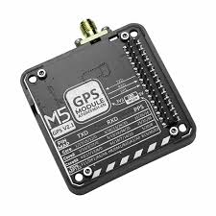
2. LEO Satellite Communication Module

Function: Transmits and receives data via low-Earth orbit satellites.
Benefit: Provides reliable communication in remote marine areas where network coverage is unavailable, and enables the transmission of emergency signals (SOS) and voice data. (6)
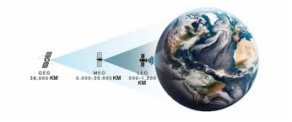

3. Microcontroller (Arduino)

Function: Controls all system components and processes data.
Benefit: Acts as the device's central processing unit, receiving data from sensors and determining when to send an alert or activate the system. (7)
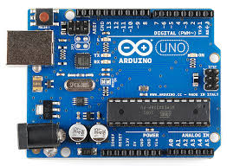
4. Sensors
a) Accelerometer / Gyroscope
Function: Measures movement and direction.
Benefit: Helps detect boat capsizing or sudden falls. (8)
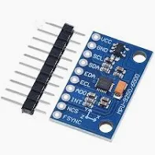

b) Impact Sensor
Function: Detects shocks.
Benefit: Detects marine accidents or collisions. (9)
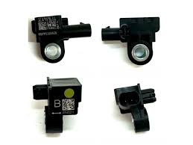

c) Water Sensor
Function: Detects the presence of water.
Benefit: Determines if a person has fallen into the water or if water has entered the device.(10)
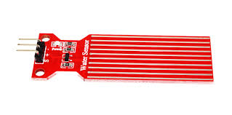

5. SOS Button
Function: Manual emergency button.
Benefit: Allows the user to call for immediate assistance in critical situations.
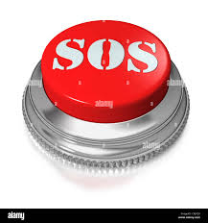

6. LED / Laser Light
Function: Emits a powerful light at night.
Benefit: Helps rescue teams visually locate a person in the dark. (11)
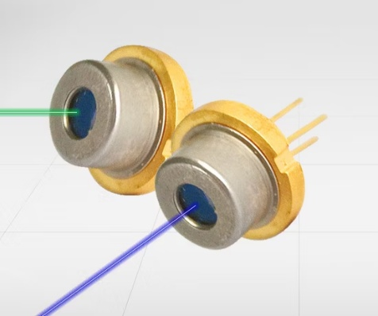

7. Solar Panel
Function: Generates power from sunlight. Benefit:
Provides a sustainable power source for the device during the day, reducing the need for frequent charging.(12)
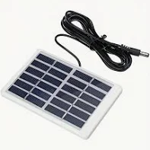

8. Rechargeable Battery
Function: Stores energy for later use.
Benefit:
Ensures the device continues to operate at night or in the absence of sunlight.
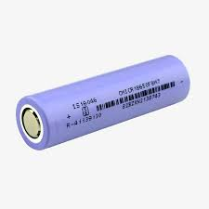

9. Waterproof Enclosure
Function: Protects internal components.(13)
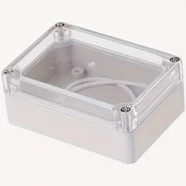
Benefit:
Protects the device from:
Water
Humidity
Salt
High temperatures

10. Buzzer (Alarm System)
Function: Emits an audible alarm.
Benefit:
Alerts nearby people to an emergency. (14)
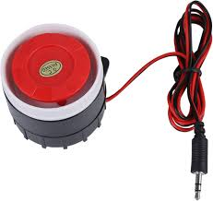

11. Antenna
Function: Amplifies the signal.
Benefit:
Improves satellite communication and increases data transmission efficiency.
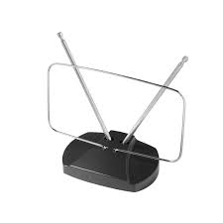
CHAPTER 3: SYSTEM DESIGN

3.1 System Operation
The operation of the proposed system begins when the device is activated and continuously monitors environmental and physical conditions. Under normal conditions, the system tracks the user’s location using GPS and analyzes surrounding data.
In the event of an emergency, such as a collision, capsizing, or manual activation of the SOS button, the system immediately determines the exact location and transmits a distress signal via LEO satellite communication. The transmitted data includes GPS coordinates, emergency status, and, if enabled, voice communication.
Simultaneously, the system activates visual signals such as LED or laser lighting to assist rescue teams during nighttime operations. The rescue authorities receive the alert, locate the victim on a digital map, and initiate response procedures.
The device remains operational through solar charging during the day and battery support at night, ensuring continuous functionality in harsh marine environments.

3.1.1 Block Diagram
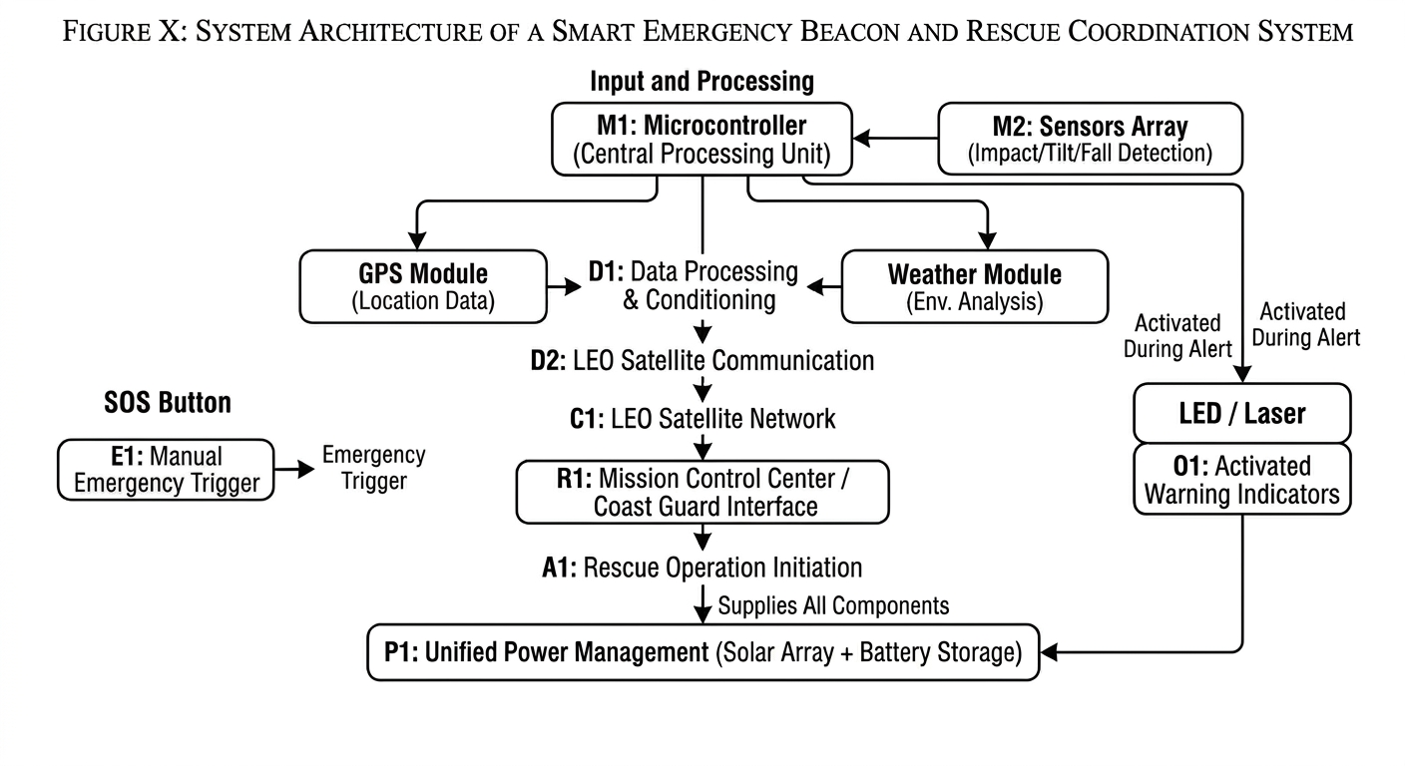

3.1.2 Block Description
- Sensors detect any hazard (fall, rollover, impact).
- Data is sent to the controller for processing.
- Location is determined via GPS.
- Data is transmitted via satellite (LEO).
- The signal reaches the rescue center for action.
- Simultaneously, the lights or emergency button are activated.
- The power system supplies all components.

3.1.3 Flowchart
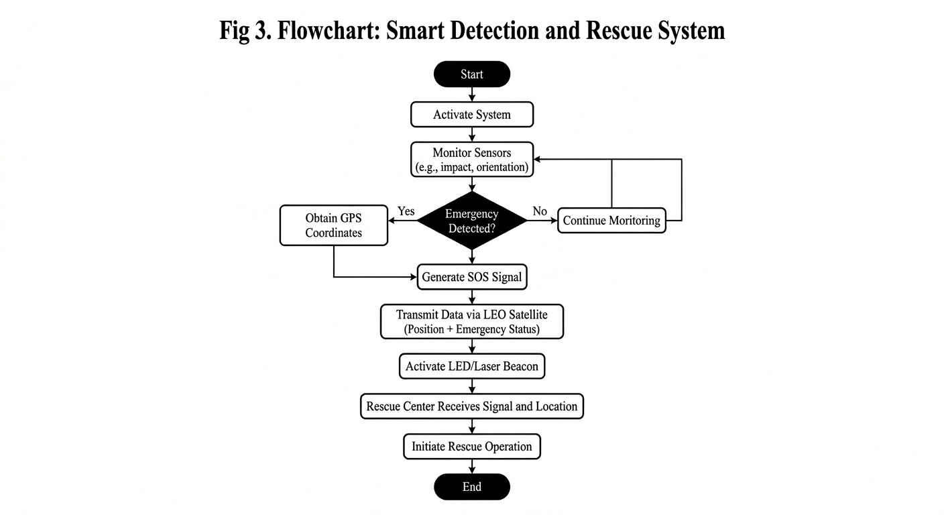

CHAPTER 4 : RESULT ANALYSIS AND DISCUSSION ON
FINDING

4.1 Presentation of Developed Solution
The developed solution is a Smart Marine Rescue Device designed to enhance safety in maritime environments. The system integrates multiple technologies, including GPS for accurate location tracking and LEO satellite communication for long-range connectivity. It is capable of sending real-time emergency alerts (SOS) along with location data to rescue authorities.

The device also incorporates smart sensors to detect critical situations such as collisions, capsizing, and falls. Additionally, the system analyzes weather and marine environmental data to predict potential hazards. The system is powered by solar energy with a backup battery, ensuring continuous operation even in harsh marine conditions. Furthermore, it includes LED/laser lighting for nighttime visibility, improving rescue efficiency.

4.2 Performance Test Analysis
The performance of the proposed system can be evaluated based on several key parameters:
- Communication Reliability: The use of LEO satellites ensures stable communication even in remote ocean areas.
- Response Time: The system provides fast emergency alert transmission, reducing rescue delays.
- Accuracy: GPS integration ensures precise location tracking.
- Energy Efficiency: Solar power combined with battery backup allows continuous operation.
- Detection Efficiency: Sensors effectively identify accidents such as impacts and capsizing.
- Overall, the system demonstrates high reliability and efficiency compared to traditional maritime safety devices.

4.3 Discussion on Findings
The findings indicate that integrating satellite communication with IoT-based sensing significantly improves maritime rescue operations. The system overcomes the limitations of traditional devices by providing real-time monitoring, automatic detection, and long-range communication.

The use of LEO satellites enhances connectivity, while smart sensors reduce dependence on manual intervention. Additionally, environmental monitoring contributes to early warning and risk prevention. These results confirm that the proposed solution is practical, scalable, and suitable for real-world maritime applications.

Advantages:
- Reliable communication in remote areas
- Real-time location tracking
- Automatic emergency detection
- Fast response and improved rescue efficiency
- Operates without internet or mobile network
- Renewable energy (solar-powered)
- Resistant to harsh marine conditions

Disadvantages:
- High cost of satellite communication
- Dependence on satellite availability
- Limited battery life in extreme conditions
- Requires maintenance and periodic checks
- Complexity of system integration

CHAPTER 5 : CONCLUSIONS & FUTURE SCOPE

5.1 Conclusions
In conclusion, the proposed Smart Marine Rescue Device provides an effective solution to enhance maritime safety. By integrating GPS, LEO satellite communication, and IoT-based sensors, the system ensures reliable emergency detection and rapid response. The device addresses key challenges in marine environments, such as lack of communication and delayed rescue operations. Therefore, this system has strong potential to reduce fatalities and improve safety in maritime activities.

5.2 Future Scope of the Project
- integration with mobile applications for real-time monitoring
- Addition of cameras for live streaming during emergencies
- Using artificial intelligence for more accurate risk analysis
- Improving energy efficiency and increasing battery life
- Expanding the device's use to include land disasters
- Supporting connectivity with multiple international rescue systems

REFERENCES

1https://www.researchgate.net/publication/403080157_Technical_Feasibility_and_Application_Prospects_of_LEO_Satellite_Communication_for_Smartphones

2https://www.researchgate.net/publication/396996453_Design_of_a_Marine_Emergency_Search_and_Rescue_System_Based_on_Beidou

3https://www.researchgate.net/publication/368596425_Improved_design_and_Implementation_of_Personal_Location_Beacon

4https://www.researchgate.net/publication/343291774_Integration_of_IoT_Technologies_in_the_Maritime_Industry?utm_source=chatgpt.com

5https://thepihut.com/products/gps-module-v2-1-with-antenna-atgm336h?srsltid=AfmBOorQ0xHn-JjT_ReGW7X5Z3dr_t2GaDRliBr3HNp3aHu2WwoR0le0

6https://www.google.com/imgres?q=2.%20LEO%20Satellite%20Communication%20Module&imgurl=https%3A%2F%2Fantesky.com%2Fwp-content%2Fuploads%2F2025%2F02%2FLEOGEOMEO-satellite-coverage-area.jpg&imgrefurl=https%3A%2F%2Fantesky.com%2Fthe-impact-of-low-orbit-satellite-technology-leo-on-modern-global-communications%2F&docid=8Hjrku1N3esqTM&tbnid=IcjXFrjaiu_F6M&vet=12ahUKEwj07PaK-uGTAxWbTKQEHV7xJrgQnPAOegQIFxAB..i&w=4536&h=1908&hcb=2&ved=2ahUKEwj07PaK-uGTAxWbTKQEHV7xJrgQnPAOegQIFxAB

7https://www.google.com/imgres?q=Microcontroller%20(Arduino)&imgurl=https%3A%2F%2Fcdn.sparkfun.com%2Fassets%2F9%2F1%2Fe%2F4%2F8%2F515b4656ce395f8a38000000.png&imgrefurl=https%3A%2F%2Flearn.sparkfun.com%2Ftutorials%2Fwhat-is-an-arduino%2Fall&docid=2yUjLiqHsbtiNM&tbnid=dMmv2AFBQqOZ8M&vet=12ahUKEwjC9OvU-uGTAxW0RaQEHXYkLjgQnPAOegQIFxAB..i&w=551&h=405&hcb=2&ved=2ahUKEwjC9OvU-uGTAxW0RaQEHXYkLjgQnPAOegQIFxAB

8https://www.google.com/aclk?sa=L&ai=DChsSEwj8krj5-uGTAxXNpf0FHRz3ArEYACICCAEQAxoCd2Y&co=1&ase=2&gclid=CjwKCAjwnN3OBhA8EiwAfpTYeq13pqhQ-3O6mszfkItQdK9YnSbZhReSzEsPXO1Fjdn3IL73uI_kCBoCp_4QAvD_BwE&cid=CAAS3gHkaFuJIhFhkhSP-rj6DpIHv7bSQi04aKI2iLwnfc4lHYnCdxcctNYCJPyZ_jsB8CV-H1-CgdbU4dHt0D-MyI2AtPQp72RAHqk-dbu8_PR_v2iVicwBaqN4bF19kAp-rSS8VCXpnxCUKKUG9BNV2WahVDY4Kcf0PnxPJKApsCjXjPHHiXEYutRf2FKtmVzbhwYPiAhgJeF-3QwIh9GUFSTOjKT4TEgsNx6_LI0fe25au5IhBa75r2V8-nSSAACTJkKwg3iLstXVmnCpFO8AIslj9-xJ_eQ0eA4K3CMwdFE&cce=2&category=acrcp_v1_32&sig=AOD64_1tlqx_gEQ9M-AQPfP36XHXmSZPLA&ctype=5&q=&nis=4&ved=2ahUKEwiloLX5-uGTAxUNOfsDHYbUDfcQ9aACKAB6BAgHEBo&adurl=

9https://www.google.com/imgres?q=%0D%0Ab)%20Impact%20Sensor%0D%0A&imgurl=https%3A%2F%2Fcdn.myshoptet.com%2Fusr%2Fwww.super-parts.eu%2Fuser%2Fshop%2Fbig%2F22923-1_201068-1ea959651-impact-sensor-for-airbag.jpg%3F694a0b05&imgrefurl=https%3A%2F%2Fwww.super-parts.eu%2F1ea959651-impact-sensor-for-airbag%2F&docid=Tq-49q--SfcREM&tbnid=ufSmTg_ZHUwMLM&vet=12ahUKEwiDjPG1--GTAxWcU6QEHaypOEQQnPAOegQIFhAB..i&w=1024&h=768&hcb=2&ved=2ahUKEwiDjPG1--GTAxWcU6QEHaypOEQQnPAOegQIFhAB

10https://www.google.com/imgres?q=Water%20Sensor&imgurl=https%3A%2F%2Fdiyables.io%2Fimages%2Fproducts%2Fwater-sensor-detector-2.jpg&imgrefurl=https%3A%2F%2Fdiyables.io%2Fproducts%2Fwater-sensor-detector&docid=m7p08bLGi_bXeM&tbnid=84kNidgXDcUq0M&vet=12ahUKEwjhoNHx--GTAxW8VqQEHai4EgAQnPAOegQIIBAB..i&w=1541&h=764&hcb=2&ved=2ahUKEwjhoNHx--GTAxW8VqQEHai4EgAQnPAOegQIIBAB

11https://m.made-in-china.com/product/650nm7mw-New-Imported-Japanese-Rohm-Laser-Diode-Ld-RLD65MPT4--719867045.html

12https://www.google.com/aclk?sa=L&ai=DChsSEwiN76qC_eGTAxUkgFAGHV55CvwYACICCAEQBRoCZGc&co=1&ase=2&gclid=CjwKCAjwnN3OBhA8EiwAfpTYeqVCsDr4djikD_uIuJclNaACLiNV5bUvE7fPHs3jY6-CxqlajJ3OfBoC0xkQAvD_BwE&cid=CAAS3gHkaEoo6q7wqRkXA5kLzHtcL_pdDO-AKKSzbhEGFHcXbKvFfXVcZHrpO3XWeM5frHcguS-LRlEqQup2QntjMc5asMCG-Zx3gGy7ufkkYhkgkEqyAbkG3fJE-lvMcHsY4pvYx6TXHjEysiH6c_G-b93YkM8CBIRj0du9T3ghLVjP-SEHC6qLducVEj6kJKGX0wBLzlMYCMVTjdsTFshRqwbUjkiVAMMxrqyRP6ZELu5FXKLTC2Q9Cbil1bveFaxZP_nW0Bk0VhgI9kD7dTU6a4AA9wgony2BoFyAq7a0JD0&cce=2&category=acrcp_v1_32&sig=AOD64_3R4FI91hrUb5qD7JHbGC1H1noMaQ&ctype=5&q=&nis=4&ved=2ahUKEwjvoKeC_eGTAxX5WkEAHVtoLLoQ9aACKAB6BAgJEB0&adurl=

13https://www.google.com/aclk?sa=L&ai=DChsSEwjw8I7b_eGTAxVw8XkEHb0JFfkYACICCAEQBxoCd2Y&co=1&ase=2&gclid=CjwKCAjwnN3OBhA8EiwAfpTYei2u7B-M7FVvRAxxSG81L6FQie_sxue3vPCXUMRRVwP3JDlEgU2nDxoC-ycQAvD_BwE&cid=CAAS3gHkaN47ZWT5PZMq2KbVSVQ3URH3Ej16YG25_UelNLo0yDKie1wXskRqMKt6-7V_2QbbpwYEzDee0Mfti6-uNOK3hevgrLFOFbNbG_Ppv6_DUtyjJoyB7hRsREbgAkJfuKxgCeFOpeIvUL8f8J8neUHA5dk7QmJGJdiE9GOLukduYPMMrkXpIB4LyhE10YeHs79CetApJo_7_JxjBlMvrYL814yHstB4fhE4kEzP-_Gv6ESJiN_1c2DXb7cNmQoHEt6dwM0VBhbQCPEWyhKKRDpeTWMnZ2EjbPmXw7n5vmg&cce=2&category=acrcp_v1_32&sig=AOD64_08xVRC4Ai6dHVNEcDW_wU2mQn81A&ctype=5&q=&nis=4&ved=2ahUKEwi96ovb_eGTAxWrdaQEHYCEKs4Q9aACKAB6BAgIECQ&adurl=

14https://www.google.com/imgres?q=Buzzer%20(Alarm%20System)&imgurl=https%3A%2F%2Fm.media-amazon.com%2Fimages%2FI%2F61roGAVkazL._AC_UF1000%2C1000_QL80_.jpg&imgrefurl=https%3A%2F%2Fwww.amazon.com%2FElectronic-Buzzer-System-Warning-Security%2Fdp%2FB0CHBJK3BZ&docid=jqQSFiwPiDY5iM&tbnid=DyG6KCOkIWy2wM&vet=12ahUKEwih6YOW_uGTAxUJAfsDHeLqL3IQnPAOegQIHRAB..i&w=1000&h=944&hcb=2&itg=1&ved=2ahUKEwih6YOW_uGTAxUJAfsDHeLqL3IQnPAOegQIHRAB

